Elf Coloring Contest
Presented by:
Sterling Recreation Authority
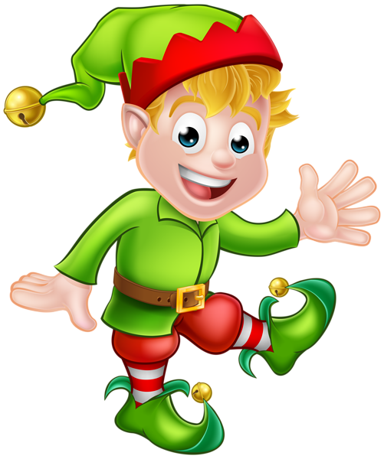
Little Elves Category (7 & under) Older Elves (8 – 12)
Coloring pages are available at the Oneco Post Office
or online at www.sterlingct.us

Please include your child’s name, age and contact #/email address
on the back of coloring page.

Coloring pages can be dropped off at the Oneco Post Office or
The Sterling Town Hall Drop Box by
December 21, 2020

Judging will take place December 22nd & 23rd 2020.
Winners will be contacted and prizes will be awarded.

