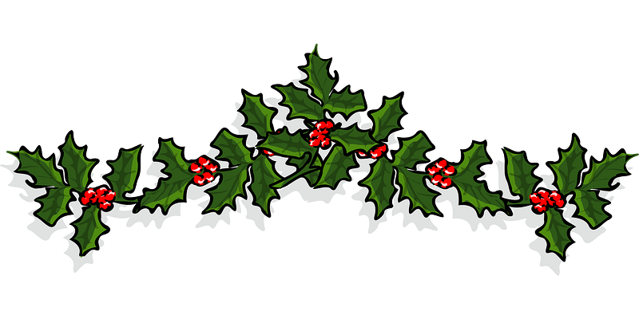Basket Drawing
To Benefit the
Sterling Community Library
Tickets are $1.00 each or 6/$5.00
Drawing: December 16th, 2021

Baby Basket Men’s Basket
Italian Basket Coffee Basket
Baking Basket Kid’s Books Basket
Adult Reading Books Home Décor Basket

Tickets available at the Library

