Town of Sterling Recreation Department
2021 Fall Program
Fall Family Bingo
Friday November 19th
6:30 P.M. – 8:00 P.M.
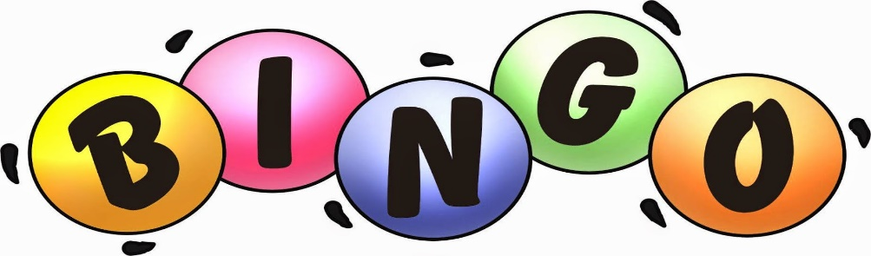
Join us for the 1st Fall Family Bingo in the Sterling Recreation gymnasium. All ages are welcome. An adult must accompany children. The 1st number will be called at 6:30 pm and the last card will begin no later than 8:00 pm. This is sure to be a fun filled evening with prizes and refreshments. There are NO cash prizes. Registration is not required for this event.

